**Random File Generator**

fid = fopen('random.txt','wt'); % 'wt' means "write text"

if (fid < 0)

error('could not open file "random.txt"');

end;

% write some stuff to file

for i=1:100

y(i) = round(rand(1)*100);

fprintf(fid,'Number = %3d\n',y(i));

end;

fclose(fid);

% file = fopen('text.txt')

% fprintf(file, int2str(for i = 1:100,

% y(i)=round(rand(1)*100)

% end))

**List of Beacon Websites**

MAST: <http://www.ansr.org/kd7lmo/www.kd7lmo.net/picobeacon.html>

DELFI C3: [www.delfic3.nl](http://www.delfic3.nl)

SWISSCUBE: <http://swisscube.epfl.ch/page17394.html>

PSK31 <http://members.tripod.com/ve2yag/id68.htm>

GPMPU 28 <http://www.awce.com/gpbeacon.htm>

Tokyo Cubesats: http://www.space.t.u-tokyo.ac.jp/cubesat/mission/spec/doc-e.html

**PicoBeacon Summary and Schematics**

**Figure 1:** PicoBeacon Schematic

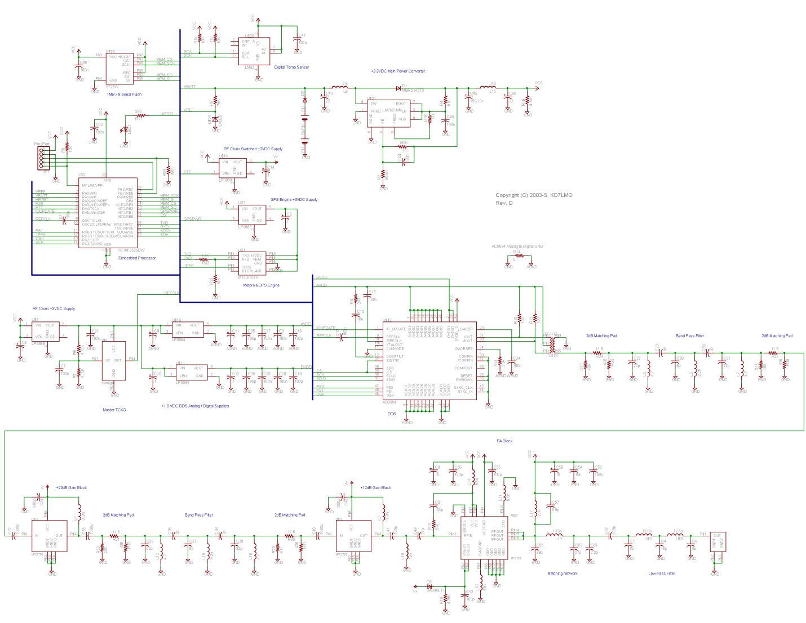

**Figure 2:** PicoBeacon Components Diagram

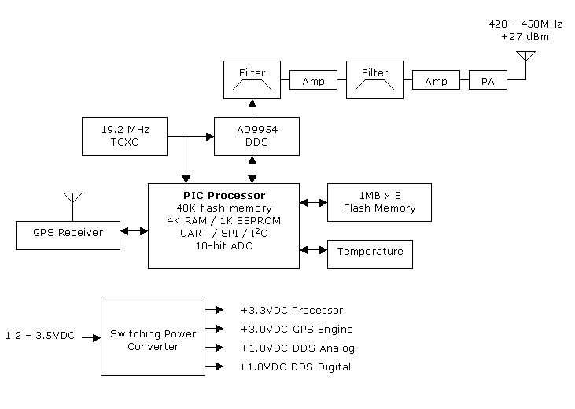

|  |  |
| --- | --- |
| **Parameter** | **Value** |
| Frequency | 437 MHz |
| Power | 0.5 W |
| Weight | 5.8 oz |
| Modulation | FSK |
| Baud rate | 9600 bps |
| Format | AX.25 |
| Dimensions | 7.62 x 8.89 cm |

|  |  |
| --- | --- |
| **Part** | **Note** |
| PIC Processor | Microchip PIC 18 F 2525 |
| Temperature Sensor | National Semiconductor LM 92 |
| RF Power Amplifier | RF Microdevices RF2192 |
| DDS | Analog Devices AD 9954 |
| Clock | 19.2 MHz TCXO |

**Source Code**

Available under COM 🡪 OSIRIS 🡪Beacon 🡪 PicoBeacon SourceCode in Sharepoint

**RF Components**

BPF: <http://minicircuits.com/pages/s-params/VBFZ-925+_VIEW.pdf>

LNA: <http://minicircuits.com/pages/s-params/ZEL-0812LN_VIEW.pdf>

**Microhard Manual**

COM 🡪 OSIRIS 🡪 Transceiver Documents 🡪 Manual

**FEKO Simulations**

COM 🡪 OSIRIS 🡪 Transceiver Documents 🡪Cube2, Monocube and Summary